GW Campus Emergency Information
GW Emergency Services: 202-994-6111
For situation-specific instructions, please refer to GW’s Emergency Procedures guide.
GW Alert
GW Alert is an emergency notification system that sends alerts to the GW community. GW requests students, faculty, and staff maintain current contact information by logging into alert.gwu.edu. Alerts are sent via email, text, social media, and other means, including the Guardian app. The Guardian app is a safety app that allows you to communicate quickly with GW Emergency Services, 911, and other resources. Learn more at safety.gwu.edu.
Protective Actions
GW prescribes four protective actions that can be issued by university officials depending on the type of emergency. All GW community members are expected to follow directions according to the specified protective action. The protective actions are Shelter, Evacuate, Secure, and Lockdown. Learn more at safety.gwu.edu/gw-standard-emergency-statuses.
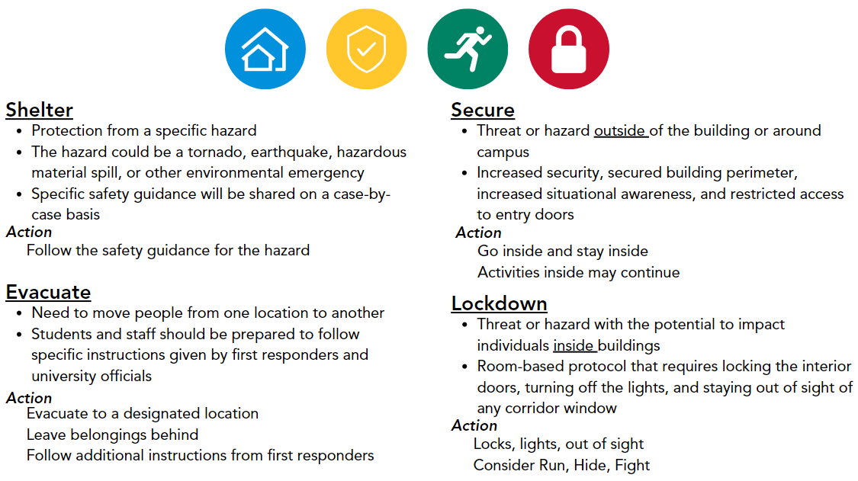
Classroom Emergency Lockdown Buttons
All classrooms have been equipped with classroom emergency lockdown buttons. If the button is pushed, GWorld Card access to the room will be disabled, and GW Dispatch will be alerted. The door must be manually closed if it is not closed when the button is pushed. Anyone in the classroom will be able to exit, but no one will be able to get in.

